We are Ready......
Beef lasagne
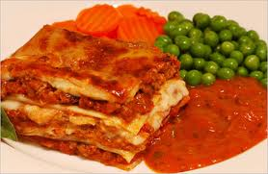
Suggested portion
Size for recipe
1–2 years – 130g
3–4 years – 170g

Ingredients – Serves 5

Onion, peeled 60g (1 small)
Garlic, peeled 1 clove
Beef, lean, minced 210g
Oregano ½ teaspoon
Tomato purée 30g (2 tablespoons)
Canned tomatoes, chopped 100g (½ x 200g can)
Water 200ml
Soft margarine 20g
Plain flour 20g
Whole milk 200ml
Lasagne sheets 90g (5–6 sheets)
Cheddar cheese, full-fat 30g
Method

1. Preheat the oven to 180ºC/350ºF/gas mark 4.
2. Chop the onion and garlic.
3. Put a large pan on a medium heat, add the mince and cook until brown. Add the onions,
garlic, oregano and tomato purée and cook for 5 minutes until the onion has softened.
4. Add the canned tomatoes and water and leave to simmer for 20 minutes.
5. Prepare a roux white sauce: in a separate pan melt the margarine on a low heat. Once it
has melted, stir in the flour cook on a low heat for 1–2 minutes. Gradually add the milk a
little at a time stirring continuously, bringing the sauce to the boil until thickened.
6. In an ovenproof dish, layer the mince and lasagne sheets and top with a layer of
white sauce.
7. Grate the cheese and sprinkle on the top. Bake in the oven for 45 minutes or until piping
hot throughout and golden on top.
Serve with vegetables

