We are ready......
Tuna and sweetcorn wholemeal pasta salad

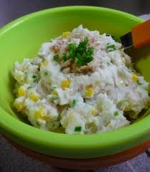
Suggested portion
Size for recipe
1–2 years – 130g

3–4 years – 170g

Ingredients – Serves 5

Wholemeal pasta 175g
Canned sweetcorn drained ½ x 198g can
(Drained weight 85g)
Tuna in spring water drained 1¼ x 185g cans
(Drained weight, 160g)
Mayonnaise, full-fat 40g (1 heaped tablespoon)
Plain yoghurt, full-fat 40g (1 tablespoon)

Method

1. Boil the pasta according to the instructions on the packet until tender.
2. Drain the pasta and rinse under cold water. Mix the pasta with the sweetcorn, tuna, mayonnaise and yoghurt.
3. Cover and chill before serving.

