We are ready......
Stewed seasonal fruit and yoghurt

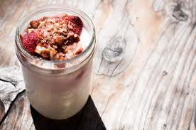
Suggested portion
Size for recipe
1–2 years – 90g
(50g yoghurt, 40g fruit)

3–4 years – 110g
(70g yoghurt, 40g fruit)

Ingredients – Serves 5

Apples, peeled and cored 100g
Blackberries 100g
Water 15ml
Yoghurt 300ml

Method

1. Wash the fruit and slice the apples.
2. Heat in a saucepan with the water on a medium heat until stewed.
3. Serve the stewed fruit with the yoghurt.

