We are ready......
Semolina and blackberry compote

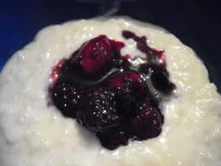
Suggested portion
Size for recipe
1–2 years – 110g
(70g semolina, 40g fruit)

3–4 years – 140g
(100g. semolina, 40g fruit)

Ingredients – Serves 5

Fresh blackberries 200g
Semolina 25g
Whole milk 375ml
Caster sugar 20g (1 tablespoon)

Method

1. Wash the blackberries. Place in a blender and blend until smooth.
2. Place the semolina and milk in a large pan and bring to the boil.
3 Stir in the sugar; reduce the heat and simmer, stirring continuously until the semolina has thickened.
4. Serve the semolina with a portion of blackberry compote.

