We are ready......
Salmon and broccoli pasta
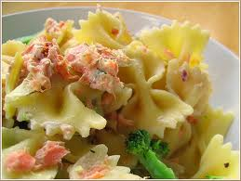
Suggested portion
Size for recipe
1–2 years – 180g

3–4 years – 210g

Ingredients – Serves 5

Salmon, fresh or canned 1 x 212g can, or 200g fresh
Onion, peeled 30g (½ small)
Broccoli 75g
Pasta, dried shapes 210g
Soft margarine 15g
Plain flour 15g
Whole milk 300ml
Full fat cheddar cheese 30g
Parsley, dried ¼ teaspoon

Method

1. Either cook the fresh salmon or prepare the canned salmon by removing all bones and skin. Finely chop the onion and cut the broccoli into small florets.
2. Boil the pasta according to the instructions on the packet then drain.
3. Cook the broccoli and onion in boiling water until just tender, for approximately 10 minutes.
4. Make the cheese sauce: heat the margarine in a saucepan and stir in the flour.
Remove from the heat and add the milk gradually and whisk until smooth. Bring the sauce to a gentle simmer, stirring all the time until it thickens. Add the grated cheese and stir until melted.
5. Combine the cheese sauce, pasta and broccoli then fold in the cooked, cooled salmon and parsley.

