We are Ready......
Roast Quorn with Tomato and Basil Sauce
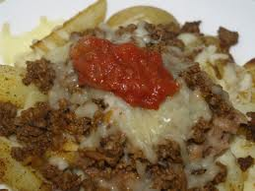
Suggested portion
Size for recipe

1–2 years – 65g

3–4 years – 85g

Ingredients – Serves 5

Quorn™ roast 250g (half a family roast)
Onion, peeled 60g (1 small)
Fresh basil 1 tablespoon
Garlic, peeled ½ cloves
Vegetable oil ½ tablespoon
Tomato purée ½ tablespoon
Canned tomatoes, chopped ½ x 200g can

Method

1. Roast the Quorn™ according to the manufacturer’s instructions.
2. Meanwhile, chop the onions, basil and garlic.
3. Heat the oil in a pan, add the onion and garlic and fry for 2–3 minutes.
4. Add the tomato purée, chopped tomatoes and basil to the pan, bring to the boil
and simmer for 15 minutes.

Serve with roast potatoes, red cabbage and parsnips

