We are ready......
Ratatouille and mozzarella

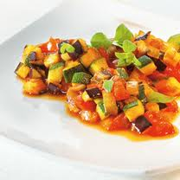
Suggested portion
Size for recipe
1-2 years – 40g ratatouille and 15g mozzarella

3-4 years – 60g ratatouille and 15g mozzarella

Ingredients – Serves 5

Onion, peeled 30g (½ small)
Garlic, peeled ½ clove
Mushrooms 30g (3 mushrooms)
Courgette 50g (½ medium)
Canned tomatoes, chopped 200g (1 x 200g can)
Dried oregano ¼ teaspoon
Dried thyme ¼ teaspoon
Water 50ml
Mozzarella 75g

Method

1. Chop the onion, garlic, mushrooms and courgette.
2. Put the onion, garlic, mushrooms, courgettes, canned tomatoes, oregano, thyme and water into a large saucepan, bring to the boil and then simmer until all the vegetables are cooked approximately 30 minutes).
3. Grate the mozzarella, and serve with ratatouille and a jacket potato.

