We are ready......
Pork and apple casserole
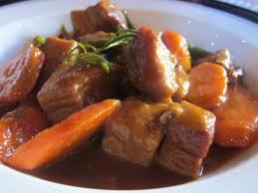
Suggested portion
Size for recipe
1–2 years – 80g

3–4 years – 120g

Ingredients – Serves 5

Onion, peeled 30g (½ small)
Fresh peppers, green and red,
Cored 40g (¼ medium)
Mushrooms 30g (3 mushrooms)
Courgette 20g (1⁄5)
Apple, eating, peeled 75g (1 small)
Vegetable oil 1 teaspoon
Minced pork 200g
Garlic powder ½ teaspoon
Corn flour 4g (1 teaspoon)
Water 100ml
Basil, dried ½ teaspoon
Canned tomatoes, chopped 100g (½ x 200g can)

Method

1. Dice the onions, mushrooms, courgettes and apples.
2. Heat the oil and fry the pork mince with the onion and garlic powder.
3. Add the peppers, courgettes and mushrooms and fry for 2 minutes.
4. Mix the corn flour with a little of the water and then add to the pan together with the basil, apples, tomatoes and the rest of the water. Cover and simmer for 25–30 minutes.

