We are Ready......
Pilchard Pasta
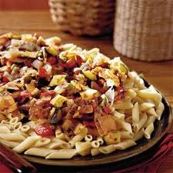
Suggested portion
Size for recipe

1–2 years – 180g

3–4 years – 240g

Ingredients – Serves 5

White pasta, shapes 190g
Canned sweetcorn, ½ x 198g can
no added salt or sugar, (drained weight, 80g)
drained
Frozen peas 80g
Canned tomatoes, chopped 1 x 200g can
Mixed herbs, dried ½ teaspoon
Canned pilchards ½ x 415g can (200g)
in tomato sauce
Tomato purée 15g (1 tablespoon)
Water 100ml

Method

1. Boil the pasta in a large pan according to the manufacturer’s instructions.
2. In a separate pan, boil the sweetcorn and peas for 5 minutes.
3. Drain the pasta and vegetables.
4. In a large pan, combine the pasta, vegetables, canned tomatoes, mixed herbs, pilchards,
tomato purée and water. Bring to the boil before serving.

