We are ready......
Mixed bean casserole

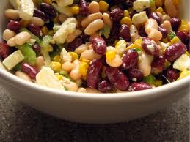
Suggested portion
Size for recipe
1–2 years – 90g

3–4 years – 130g

Ingredients – Serves 5

Onion, peeled 30g (½ small)
Celery 30g (1 stick)
Carrots, peeled 30g (1 small)
Garlic, peeled ½ cloves
Vegetable oil ½ tablespoon
Canned red kidney beans, 1 x 225g can
no added salt or sugar, drained (drained weight 130g)
Canned butter beans, no 1 x 225g can
added salt or sugar, drained (drained weight 125g)
Flour, wholemeal 15g (½ tablespoon)
Canned tomatoes, chopped 200g (1 x 200g can)
Tomato purée ½ tablespoon
Mixed dried herbs ½ teaspoon
Water, boiling 150ml

Method

1. Preheat the oven to 180ºC/350ºF/gas mark 4.
2. Chop the onion, celery, carrots and garlic.
3. Heat the oil in a frying pan, add the onions and fry until softened.
4. Add the celery, carrots and garlic and fry for 3–4 minutes.
5. Stir the flour, beans, chopped tomatoes, tomato purée, herbs and boiling water into the pan.
6. Pour into an ovenproof dish and cook for about 30–45 minutes.

