We are Ready......
Lamb Curry
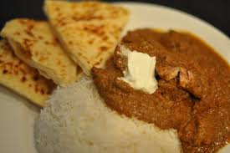
Suggested portion
Size for recipe
1–2 years – 85g

3–4 years – 115g

Ingredients – Serves 5

Onion, peeled 75g (1 small)
Carrot, peeled 30g (1 small)
Fresh tomatoes 40g (½ medium)
Vegetable oil ½ tablespoon
Lamb, lean, diced 250g
Tomato purée 1 tablespoon
Ground turmeric 1 teaspoon
Curry powder ½ heaped teaspoon
Chilli powder ½ teaspoon
Water 250ml

Method

1. Chop the onion, carrot and tomatoes.
2. Heat the oil in a pan and add the diced lamb. Cook until browned.
3. Add the onion, carrots and tomatoes and cook for 5 minutes.
4. Add the tomato purée, turmeric, curry powder, chilli powder and water. Bring to the
boil and simmer for 30 minutes or until the lamb is cooked and the vegetables are soft.
Serve with Serve with brown rice and tomato and coriander salad

