We are ready......
Warm winter fruit salad

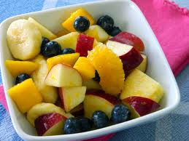
Suggested portion
Size for recipe
1–2 years – 40g

3–4 years – 40g

Ingredients – Serves 5

Fresh pear, peeled 80g (½ medium)
Fresh orange, peeled 80g (½ medium)
Cranberry juice 50ml
Ground cinnamon 1 teaspoon
Fresh apple, peeled 80g ((½ medium)
Banana Medium
Blueberries 50g

Method

1. Core the pear and apple then break the orange into segments. Chop the fruit.
2. Warm the fruit, juice and cinnamon in a large pan on a low heat until the fruit has softened.
3. Add chopped banana and blueberries and serve.

