We are Ready......
Fish Pie with Sweet Potato Topping
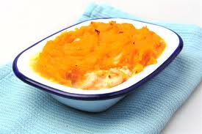
Suggested portion
Size for recipe
1–2 years – 145g

3–4 years – 195g

Ingredients – Serves 5

Sweet potato, peeled 350g
White, floury potatoes, peeled 100g
Salmon, fresh 80g
Haddock, fresh 80g
Smoked haddock, fresh 50g
Whole milk 250ml
Soft margarine 20g
Plain flour 15g

Method

1. Preheat the oven to 180ºC/350ºF/gas mark 4.
2. Chop the potato into 2cm cubes. Boil in water for 15 minutes or until soft.
3. Meanwhile put the salmon, haddock and smoked haddock in a large pan, cover with the
milk (reserving some for the mashed potato) and simmer for 20 minutes or until the fish
is cooked. Remove the fish, check for bones and set aside. Reserve the milk.
4. Drain the potatoes and then mash with enough margarine and milk to make a
smooth consistency.
5. Prepare a roux white sauce: melt the remaining margarine in a pan on a low heat.
Once the margarine has melted, add the flour and mix well. Gradually add the milk
used to poach the fish to the margarine and flour mixture, stirring continuously until
the sauce is smooth and thick.
6. Flake the fish into the white sauce, taking care to remove all bones.
7. Pour the fish mixture into a large ovenproof dish and top with the mashed potato.
8. Bake in the oven for 30 minutes or until piping hot throughout.

Serve with Swede and cauliflower

