We are ready......
Cocoa and beetroot cake

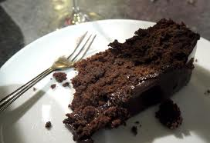
Suggested portion
Size for recipe
1–2 years – 40g

3–4 years – 60g

Ingredients – Serves 5

Beetroot, raw, peeled 65g
Cocoa powder 35g (1½ tablespoons)
Wholemeal flour 100g
Baking powder 1½ teaspoons
Bicarbonate of soda ½ teaspoon
Vegetable oil 60ml
Caster sugar 100g
Egg 100g (2 medium)

Method

1. Preheat the oven to 200ºC /400ºF/gas mark 6. Grease and line a cake tin .
2. Wash and grate the beetroot.
3. Mix the cocoa, flour, baking powder, bicarbonate of soda, oil, caster sugar and egg in a large bowl and beat until smooth and light in colour
4. Stir in the beetroot.
5. Pour into the cake tin and bake in the oven for approximately 30 minutes.

