We are ready......
Chickpea and vegetable curry

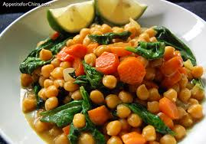
Suggested portion
Size for recipe
1–2 years – 110g

3–4 years – 130g

Ingredients – Serves 5

Onion, peeled 60g (1 small)
Garlic, peeled ½ cloves
Vegetable oil ½ tablespoon
Flour, plain 15g (1 tablespoon)
Curry powder ½ tablespoon
Cumin, ground ½ teaspoon
Coriander, ground ½ teaspoon
Tomato purée ½ tablespoon
Water 300ml
Desiccated coconut 7g (½ tablespoon)
Canned chickpeas, no added ¾ x 400g can
salt or sugar, drained (drained weight,175g)
Vegetables, mixed frozen 150g

Method

1. Chop the onion and garlic.
2. Heat the oil in a large pan, add the onion and garlic and cook until soft.
3. Stir in the flour, curry powder, cumin, with coriander and tomato purée. Mix until blended into a paste.
4. Gradually stir the water into the mixture, until the desired consistency is achieved.
5. Add the coconut, chickpeas and vegetables and simmer for approximately 45 minutes.

