We are Ready......
Chickpea Curry
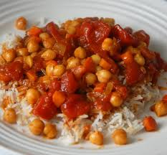
Suggested portion
Size for recipe
1–2 years – 85g

3–4 years – 115g

Ingredients – Serves 5

Onion, peeled 75g (1 small)
Carrot, peeled 30g (1 small)
Fresh tomatoes 40g (1 small)
Vegetable oil ½ tablespoon
Tomato purée 1 tablespoon
Ground turmeric 1 teaspoon
Curry powder ½ heaped teaspoon
Chilli powder ½ teaspoon
Water 200ml
Canned chickpeas, no added 1 x 400g can
salt or sugar, drained (drained weight, 240g)

Method

1. Chop the onion, carrot and tomatoes.
2. Heat the oil in a pan, add the onion, carrots and tomatoes and cook for 5 minutes.
3. Add the tomato purée, turmeric, curry powder, chilli powder, water and chickpeas.

Bring to the boil and simmer for 25 minutes or until the vegetables are soft.

Serve with brown rice and tomato and coriander salad

