We are ready......
Chicken and vegetable couscous salad

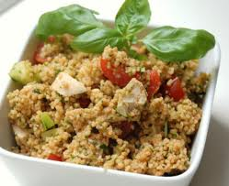
Suggested portion
Size for recipe
1–2 years – 130g

3–4 years – 170g

Ingredients – Serves 5

Couscous 180g
Water 225ml
Cooked chicken 150g
Fresh peppers, cored 60g (½ small)
Fresh tomato 85g (1 medium)
Fresh coriander ½ teaspoon
Fresh parsley ½ teaspoon
Cucumber 60g
Olive oil ½ tablespoon

Method

1. Boil the water and pour over the couscous in a bowl. Cover with cling film and leave to stand for 5 minutes or until all the water has been absorbed.
2. Meanwhile, chop the remaining ingredients.
3. When the couscous is ready, fluff with a fork and stir in the chopped chicken, vegetables, herbs and olive oil. Chill and serve.

