We are Ready......
Chicken Risotto
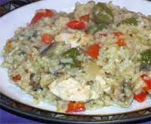
Suggested portion
Size for recipe

1–2 years – 145g

3–4 years – 195g

Ingredients – Serves 5

Onion, peeled 60g (1 small)
Garlic, peeled 1 clove
Fresh red pepper, cored 100g (1 small pepper)
Vegetable oil ½ tablespoon
Chicken breast, diced 200g
White rice 150g
Water 300ml
Frozen peas 50g
Fresh parsley 3 sprigs

Method

1. Chop the onion, garlic and pepper.
2. Heat the oil in a pan, add the onion and garlic and cook until softened.
3. Add the diced chicken and cook for 10 minutes.
4. Add the peppers and rice and fry for a few minutes.
5. Pour over ¾ of the water and cook until almost all the water has been absorbed
by the rice.
6. Add the frozen peas and gradually add the remaining water until the rice is soft
and the risotto is creamy.
7. Chop the parsley and stir into the risotto before serving.

Serve with grated parmesan

