We are Ready......
Chicken dinner
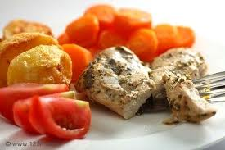
Suggested portion
Size for recipe
1–2 years – 30g chicken

3–4 years – 40g chicken

Ingredients – Serves 5

Chicken breast 250g
Gravy granules 5g
Water 100ml

Method

1. Preheat the oven to 190ºC/375ºF/gas mark 5.
2. Lay the chicken breasts in a roasting tin and cook for 20–25 minutes depending on
the size of the chicken breast.
3. Check that the meat is cooked by inserting a skewer. The meat is ready when the juices
run out clear or a meat thermometer has recorded a temperature of 180ºF (83ºC).
4. When the chicken is ready to serve, make up the gravy granules with boiling water
according to the manufacturer’s instructions.

Serve with roast potatoes, carrots and chopped tomatoes

