We are ready......
Broccoli and lentil pasta

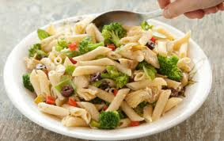
Suggested portion
Size for recipe
1–2 years – 170g

3–4 years – 230g

Ingredients – Serves 5

Garlic, peeled ½ cloves
Onion, peeled 60g (1 small)
Broccoli 65g
Vegetable oil ½ tablespoon
Canned tomatoes, chopped 200g (1 x 200g can)
Dried mixed herbs ½ teaspoon
Water 200ml
Red lentils, dried 65g
Cream cheese, full-fat 60g (2 tablespoons)
White pasta, dried shapes 210g

Method

1. To make the tomato sauce, first chop the garlic and onion.
2. Wash the broccoli and break into florets.
3. Heat the oil in a saucepan, add the onion and garlic and soften for 5 minutes.
4. Add the broccoli, tomatoes, mixed herbs, water and lentils and cook uncovered for 12 minutes.
5. Melt the cream cheese by stirring it into the broccoli and tomato sauce.
6. Meanwhile cook the pasta according to the instructions on the pack.
7. Mix the cooked pasta with the broccoli and lentil sauce.

