We are ready......
Beef and vegetable enchiladas

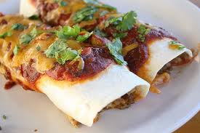
Suggested portion
Size for recipe
1–2 years – 120g

3–4 years – 160g

Ingredients – Serves 5

Onion, peeled 60g (1 small)
Fresh red pepper, cored 80g (½ medium)
Mushrooms 20g (2 mushrooms)
Vegetable oil ½ tablespoon
Canned tomatoes, chopped 200g (1 x 200g can)
Garlic purée ½ teaspoon
Tomato purée 1 teaspoon
Water 50ml
Dried mixed herbs ¼ teaspoon
Frying beef steak 210g
Tortilla wraps 150g (approx 2½ large wraps)
Cheddar cheese, full-fat 50g

Method

1. Preheat the oven to 220ºC, 425°F, gas mark 7.
2. Wash and chop the onion, red pepper and mushrooms.
3. Heat the oil in a large pan and add the onions. Cook until softened (approximately 5 minutes).
4. Add the mushrooms and peppers and cook for a further 10 minutes. When cooked remove from the heat and blend the vegetables.
5. Place the blended vegetables back into the pan with the canned tomatoes, garlic purée, tomato purée, water and herbs and simmer on a low heat for 30 minutes.
6. Meanwhile, slice the beef into thin strips and fry in a separate pan until browned. Add to the tomato and vegetable mixture.
7. In an oven proof dish, layer the sauce and tortilla, repeating to the top. Finish with the sauce and sprinkle the cheese on top.
8. Bake in the oven for around 30 minutes until the cheese has melted and turned golden.

