We are ready......
Beef bolognaise
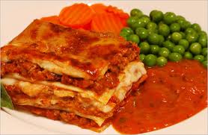
Suggested portion
Size for recipe
1–2 years – 90g

3–4 years – 130g

Ingredients – Serves 5

Onion, peeled 60g (1 small)
Fresh peppers, red or green,
cored 80g (½ medium)
Olive oil ½ tablespoon
Basil, fresh 1 teaspoon
Canned tomatoes, chopped 200g (1 x 200g can)
Lean minced beef 210g
Mushrooms 60g
Water 100ml

Method

1. Preheat the oven to 200ºC /400ºF/gas mark 6.
2. Dice the onion and pepper and place on a large baking tray. Drizzle with half the olive oil, sprinkle with the basil and roast in the oven for 20 minutes.
3. Remove the vegetables from the oven, cover and leave to cool. Once cool, mix with the canned tomatoes and blend until smooth.
4. Meanwhile heat the remaining olive oil in a pan, add the mince and cook until brown.
Skim the fat from the mince and discard.
5. Wash and dice the mushrooms then add these along with the blended vegetables and water to the mince.
6. Bring to the boil and simmer for 20 minutes.
7. Serve with boiled pasta.

