We are ready......
Banana and raisin flapjack

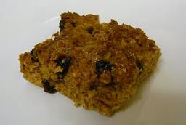
Suggested portion
Size for recipe
1–2 years – 40g

3–4 years – 60g

Ingredients – Serves 5

Banana, peeled 200g (2)
Soft margarine 80g
Caster sugar 50g (2½ tablespoons)
Golden syrup 25g (1 tablespoons)
Oats, rolled 180g
Raisins 40g

Method

1. Preheat the oven to 170ºC/325ºF/gas mark 3. Grease a baking tray.
2. Chop the bananas.
3. Melt the margarine, sugar and syrup in a large saucepan over a medium heat.
4. Add the oats, banana and raisins and combine well.
5. Place the mixture onto the baking tray and press the mixture into the tin.
Bake in the oven for 20–25 minutes.

