We are ready......
Banana and cinnamon rice pudding

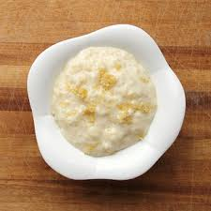
Suggested portion
Size for recipe
1–2 years – 100g

3–4 years – 140g

Ingredients – Serves 5

Pudding rice 75g
Caster sugar 30g (1½ tablespoons)
Whole milk 600ml
Banana 400g (4)
Cinnamon, ground 1 teaspoon

Method

1. Preheat the oven to 160ºC/325ºF/gas mark 3 and grease an ovenproof dish.
2. Wash the rice in a sieve and put it in the dish with the sugar.
3. Heat the milk in a pan and pour over the rice and sugar.
4. Bake in the oven for 1½–2 hours until the rice is tender.
5. Place the bananas in their skins on a baking tray and bake in the oven for 30 minutes.
6. After 30 minutes, remove the bananas from the oven, scoop out the banana flesh from the skins. Blend the banana flesh and cinnamon to a smooth purée. Combine with the rice pudding or serve separately.

