We are ready......
Apple and Rhubarb Crumble

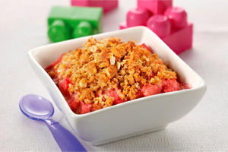
Suggested portion
Size for recipe
1–2 years – 50g

3–4 years – 70g

Ingredients – Serves 5

solid apple pack) peeled and cored 200g (1 large)
Fresh rhubarb 200g (2 stalks)
Caster sugar 20g (1 tablespoon)
Soft margarine 50g
Plain flour 80g (4 tablespoons)
Wholemeal flour 30g (1½ tablespoons)
Dark brown sugar 50g (2½ tablespoons)
Oats, rolled 20g

Method

1. Preheat the oven to 190ºC/375ºF/gas mark 5.
2. Chop the apples into 2cm slices and rhubarb into 4cm lengths and lay on the bottom of an ovenproof dish. Sprinkle with the caster sugar.
3. Prepare the crumble mixture: gently rub the margarine into the flour and brown sugar, then add the oats.
4. Sprinkle the mixture over the fruit and level ensuring all the fruit is covered.
5. Bake in the oven for 35 minutes.

